This document is merely to point out the differences in confessional count numbers between my findings and the official numbers posted on Survivor Sucks. The guidelines I use can be found [here](https://docs.google.com/document/d/18ofsPiVWxSejzSjEGlU8KEx4Og2ddEJScCV23RsCPIA/edit?usp=sharing).

**Survivor Sucks Original Season 28 Counts** ([link](https://goo.gl/photos/yh2batcsPQfugrbeA))

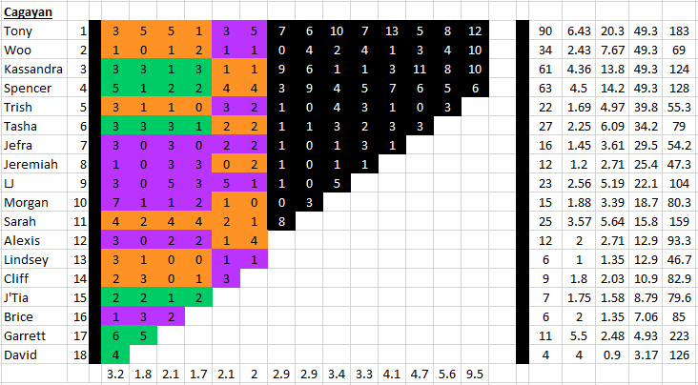

**My Season 28 Counts** ([link](https://goo.gl/photos/YBYyYzw23NwfQs516))

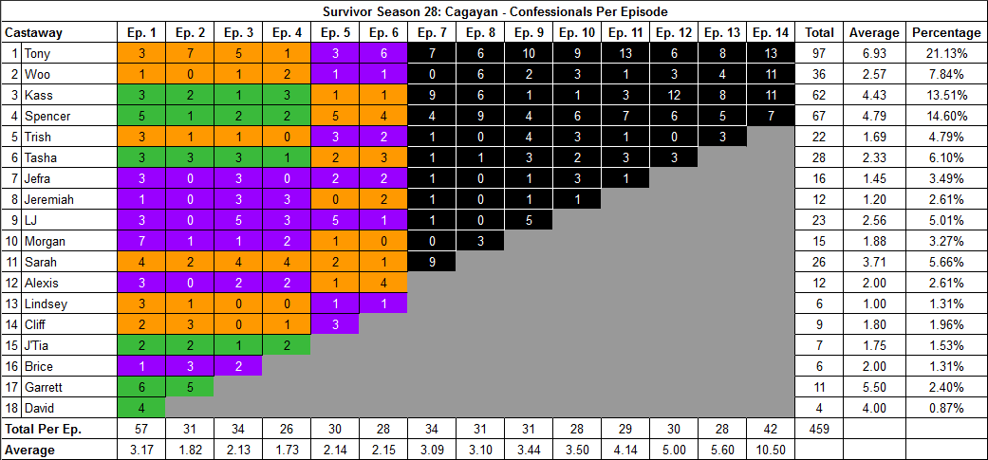

[Survivor Sucks Season 28 thread](http://survivorsucks.com/topic/111709).

**Differences**

[Episode 02](https://docs.google.com/document/d/1OhwAm4uq1g6PSeoG5CsjE711AXEgYeMwI8mcH0sPrJo/edit?usp=sharing)

* **Kass:** **2 (-1)** Confessional #3 has a 9s gap.
* **Tony:** **7 (+2)** Two sets of consecutive confessionals with 14s gaps each (#15 → 16, #18 → 19).
  + Confessional #16 has a combination of two different locations of “confessional time” with an “on the fly” confessional on the middle. Combined, they don’t have a significant gap in between. Depending on how you count confessionals, this may be further divided into an additional confessional as explained below:
    - First “confessional time” location (beach) ends at 57:27
    - This is followed by an “on the fly confessional” where Tony narrates directly to the camera as he builds the spy shack. This starts at 57:29 and ends at 57:47.
    - Second “confessional time” location (jungle) starts at 57:48.
  + Confessional #19 has Tony looking directly at the camera narrating, accompanied by him reading the idol clue.

[Episode 05](https://docs.google.com/document/d/1_nKGzygyT_wq1Kan9rAreu4T2q4J2TCtNpSZi1Kxbi4/edit?usp=sharing)

* **Spencer: 5 (+1)** Has three consecutive confessionals with gaps of 14s (#14 → 15) and 15s (#15 → 16).
* **Note:** Lindsey’s sole confessional happens at the shore while she does the dishes and looks directly at the camera (#9).

[Episode 06](https://docs.google.com/document/d/1I07NQgx39g0Q7f8SriZaOaVu5NvKkOmIebvj1-pambo/edit?usp=sharing)

* **Tasha: 3 (+1)** Two consecutive confessionals with a 10s gap (#7 → 8).
* **Tony: 6 (+1)** Two consecutive confessionals with a 15s gap (#9 → 10). Confessionals #9 also has a 9s gap in it.

[Episode 07](https://docs.google.com/document/d/1i8lnlMyiEbTMx0JhOdUhHWJOfQ9WlC0hX8ykJErwWfk/edit?usp=sharing)

* **Sarah: 9 (+1)** Two consecutive confessionals with a 12s gap (#3 → 4).
* **Spencer: 4 (+1)** Two consecutive confessionals with an 11s gap (#9 → 10).

[Episode 08](https://docs.google.com/document/d/1ILkfXq2zZimc43MpeypZDiJq1_9U-mM0ouVs2iNXKIk/edit?usp=sharing)

* **Woo: 6 (+2)** Five consecutive confessionals. #18 → 19 has a 12s gap with the rest over 15s.
* **Note:** Tasha has a single “on the fly” confessional while looking for the idol where she looks directly at the camera and narrates (#24). Some don’t count this.

[Episode 10](https://docs.google.com/document/d/1T-C6ceGW5i3cd1E_8LThTzOcank_XWMB4WWsUDWBrzo/edit?usp=sharing)

* **Spencer: 6 (+1)** Three consecutive confessionals with 13s gap (#26 → 27) and 11s gap (#27 → 28).
* **Woo: 3 (-1)** Confessional #9 has a 9s gap.
* **Tony: 9 (+2)**
  + Three consecutive confessionals with >15s gap (#3 → 4) and 11s gap (#4 → 5).
  + Three consecutive confessional with 12s gap (#20 → 21) and 13s gap (#21 → 22). Confessional #21 also has a 9s gap.

[Episode 12](https://docs.google.com/document/d/1dy9OWo0csRGIFwZOXODeCpck6gdBEhUGEF-9yK5tgvI/edit?usp=sharing)

* **Kass: 12 (+1)** Has various consecutive confessionals but they are all over 15s, except for one that has a 14s gap (#1 → 2). She also has a voice over (#28).
* **Tony: 6 (+1)** No significant gap. Confessional #23 is a voice over.

[Episode 14](https://docs.google.com/document/d/118oVXQTfKMZcIXXwdg-H0K9vkzhrSIqoPpuEFVJ086U/edit?usp=sharing)

* **Spencer: 7 (+1)** Two consecutive confessionals with 11s gap (#20 → 21).
* **Kass: 11 (+1)** Has various gaps. The shortest is a 12s gap (#13 → 14). Others are 13s, 14s and > 15s long.
* **Woo: 11 (+1)** Has two sets of two consecutive 12s gaps (#10 → 11) & (#36 → 37).
* **Tony: 13 (+1)** Has two 11s gaps from consecutive confessionals: (#8 → 9) & (#29 → 30). Also has a 10s gap (#31 → 32).

**No Change**

* [Episode 01](https://docs.google.com/document/d/1-ovIU33W574u0q6hIyFSMj7w8myPkBeIm0bNrdB3qSc/edit?usp=sharing)
* [Episode 03](https://docs.google.com/document/d/1H4HVZHuUJTW_dfxUbBR8833i1o7lFi8UoXpgHPC3eNQ/edit?usp=sharing)
* [Episode 04](https://docs.google.com/document/d/182ZKCUI6oLc7GdC4jv1rTQiYPsocn2zv0k3wCZCINos/edit?usp=sharing)
* [Episode 09](https://docs.google.com/document/d/1Am6swIZ7BtHgv_KFWcwpvizBYbI1XzFu-1KNi4eqjHg/edit?usp=sharing)
* [Episode 11](https://docs.google.com/document/d/10DZlNqhPGUSwURK9iRdMhkOr8ZGiW6u-v8GxLFkx4WI/edit?usp=sharing)
* [Episode 13](https://docs.google.com/document/d/1rlPtuXOqzNWjtM5Bpqe8nzhicyNbvpj058f0wPBgr1w/edit?usp=sharing)

|  |  |  |
| --- | --- | --- |
| **Castaway** | **Count** | **Change** |
| Sarah | 26 | (+1) |
| Tasha | 28 | (+1) |
| Spencer | 67 | (+4) |
| Kass | 62 | (+1) |
| Woo | 36 | (+2) |
| Tony | 97 | (+7) |
| **Total** | **459** | **(+16)** |

**Revised Sucks Counts** ([link](https://goo.gl/photos/2KA96nPNfo3dYs8r7))

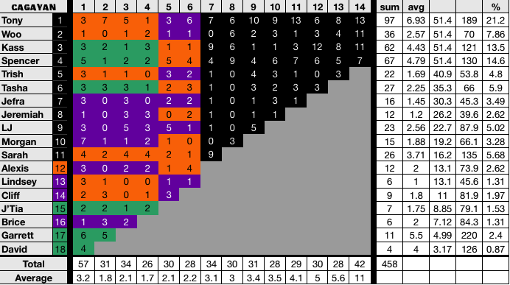

**Differences:** All my findings are reflected in the verified counts.

* Episode 8: As explained above, Tasha has an “on the fly” confessional while searching for the idol where she looks directly at the camera and briefly narrates. This wasn’t counted on the revised version. This exclusion decreases Tasha’s count to 27 (-1) and the season count to 458 (-1).